Student Name:
Instructor’s Name:
University:
Date:
Anatomy Assignment
One: Differentiate between the terms: signs and symptoms. Give appropriate examples.
Signs are objective pieces of evidence of disease while symptoms are subjective pieces of evidence of disease. In other words, a sign is evidence of disease that can be observed by another person, usually a health care worker. For example, fever is an objective observation of elevated core body temperature. Conversely, a symptom is evidence of disease that only the sick person is aware of. For example, a feeling of hotness of the body or a headache is only a symptom since only the sufferer is aware.
Two: Pick three bones from three different body regions and define two different surface markings on those bones. So, define six surface markings.
A. Mandible
- Mandibular notch – the curvature of the superior end of the mandibular ramus between the condylar and coronoid processes of the bone.
- Mylohyoid ridge – slanting ridge on the medial surface of the body and inferior ramus for the attachment of the mylohyoid muscle.
B. Zygomatic bone
- Maxillary process – thing projection medially that forms the inferior border of the orbit and articulates with the maxillary bone.
- Infraorbital notch – small depression on the anterior surface of the bone that allows for passage of the infraorbital neurovascular bundle.
C. Humerus
- Greater tubercle – a large roughening lateral to the head of the humerus for attachment of three rotator cuff muscles – infraspinatus, supraspinatus, and teres minor.
- Lesser tubercle – a large roughening medial to the greater tubercle. The attachment site of the subscapularis muscle.
D. Scapula
- Coronoid process – antero-lateral projection that is curved and hook-like and extends from the superior border of the scapula.
- Glenoid fossa – concave depression on the lateral surface of the bone for articulation with the humerus in the shoulder joint.
E. Femur
- Fovea capitis femoris – small circular depression on the medial surface of the femoral head. It is the attachment site of the ligamentum teres.
- Intertrochanteric line – a slanting ridge on the anterior surface of the upper femur spanning the distance between the lesser trochanter and the greater trochanter. It is the attachment site for the capsule of the hip joint.
F. Tibia
- Tibial tuberosity – a raised and roughened area on the anterior part of the tibia on the superior portion of the bone just below the condyles.
- Medial malleolus – projection on the inferior part of the tibial bone on the medial side. Forms the ankle joint.
Three: Explain/define the terms: cold sweat, Babinski sign, greenstick fracture, motion sickness.
Cold sweat – refers to the watery sweating induced by sudden physical or psychological stress that activates the adrenergic fight or flight response.
Babinski sign – this refers to the extension or dorsiflexion of the big toe in response to firm stroking of the sole. It is a normal response in neonates. It could indicate the presence of an upper motor neuron lesion in adults.
Greenstick fracture – a type of fracture in which the bone bends considerably before breaking. It is common in young and soft bones.
Motion sickness – a disruption of the ability of the inner ear to maintain balance due to repetitive movement when one is traveling in various locomotives. Usually presents with dizziness, nausea, and vomiting upon traveling.
Four: With labeled diagrams, describe the structure of the following tissues: adipose tissue, simple squamous epithelium, keratinized stratified squamous epithelium, hyaline cartilage, and fibrocartilage. Discuss their functions with reference to their locations.
Adipose tissue
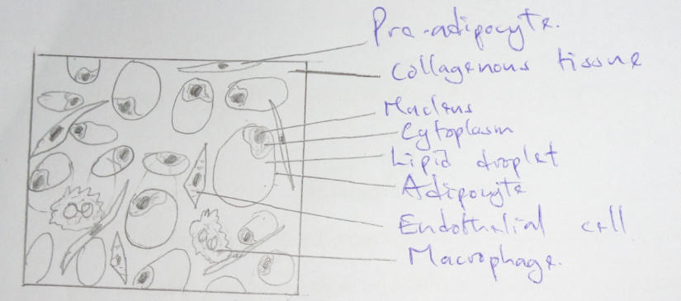
Adipose tissue serves as a store of energy in the form of lipids. Most of the adipose in the body is arranged in a subcutaneous layer. This layer acts as an insulator and a mechanical pad.
Simple squamous epithelium
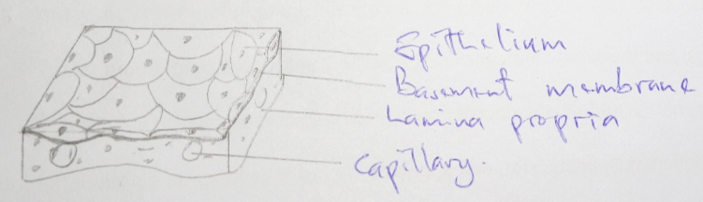
Mainly found in areas of the body where transport and absorption of substances occur like the kidneys and lungs. Allows for ease of diffusion and osmosis.
Keratinized stratified squamous epithelium
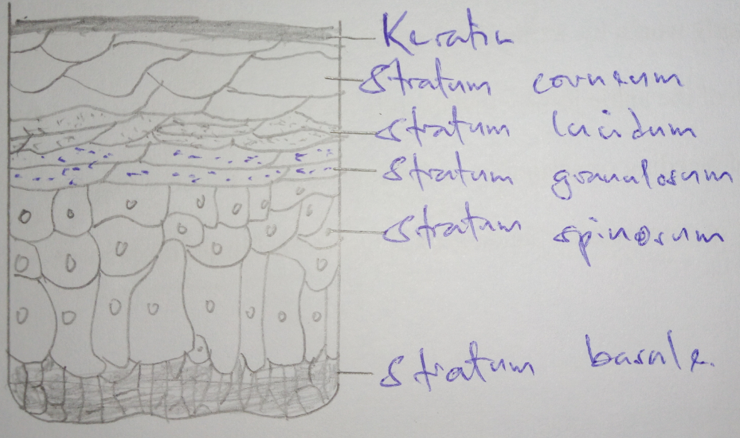
Located in parts of the body that are exposed to constant stress and tension such as the skin and the vaginal epithelium. Its toughness provides protection.
Hyaline cartilage
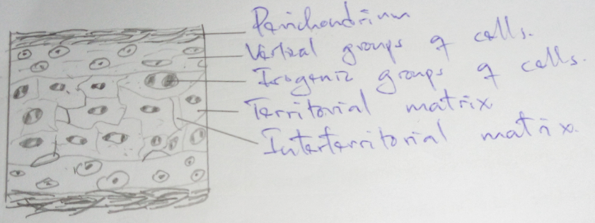
Found on the articular surfaces of bones. Allows for smooth gliding of bone surfaces on each other.
Fibrocartilage
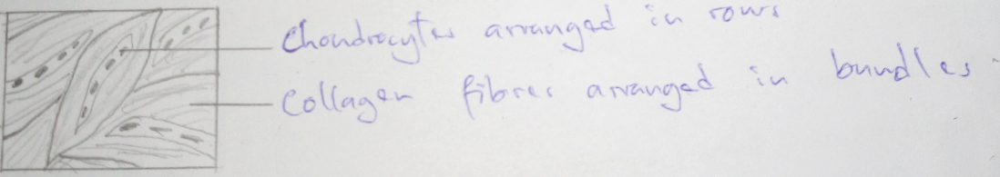
It is located in areas that require both toughness and flexibility such as the pubis symphysis and the intervertebral discs. It is mechanically tough but more flexible than bone.
Five: With a labeled diagram, discuss in detail the structure of the human skin.
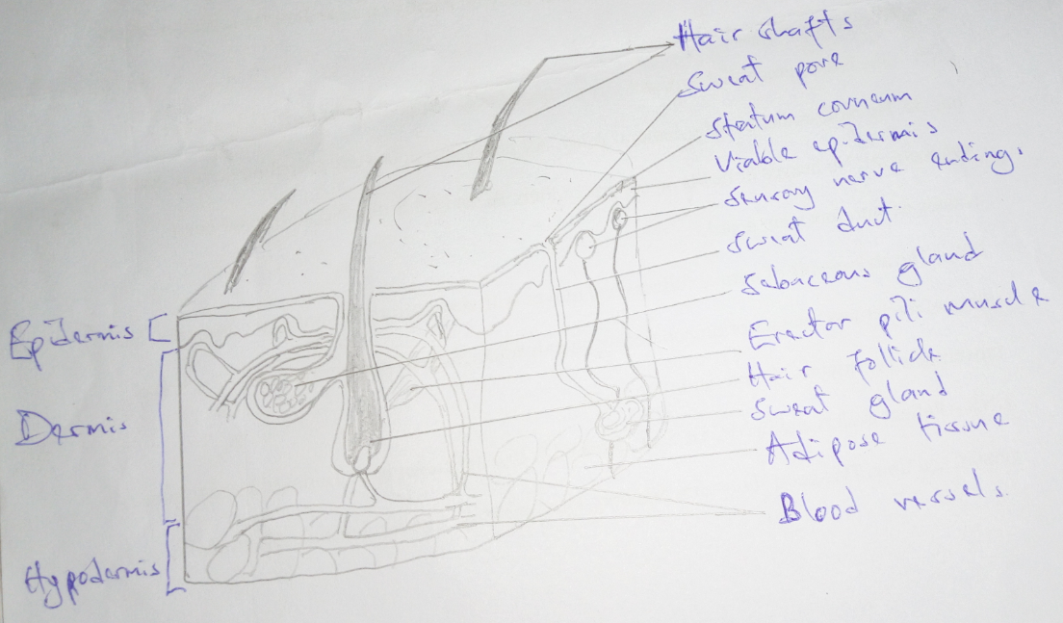
The skin is organized into two layers: the epidermis and the dermis. The hypodermis is located just below the dermis. The epidermis is comprised of multiple layers of squamous cells making a keratinized stratified squamous epithelium. The cells of the basal layers are actively mitotic and give rise to the cells of the other layers. Most cells of the outermost layer are dead. The dermis is organized into the papillary dermis and the reticular dermis. Collagenous connective tissue dominates both layers. The blood vessels in the dermis supply the epidermis. The dermis also has various skin appendages such as nerve endings, hair follicles, sebaceous glands, and sweat glands. Hair follicles are closely associated with sebaceous glands and the erector pili muscles. Sweat ducts lead from sweat glands and open on the skin surface.
Six: Explain the basis for: taste aversion, rigor mortis
Taste aversion – it is a form of classical conditioning. If an animal takes a certain food substance and gets unfavorable symptoms such as nausea and vomiting several times, then it associates the taste of that food with illness hence avoidance of that taste in the future.
Rigor mortis – it is the muscle rigidity that occurs after death. It is driven by the absence of failure of respiration, hence, the absence of ATP. The absence of ATP and other cellular changes after death lead to the release of calcium ions into the cytosol. The calcium ions change the conformation of the troponin-tropomyosin complex hence allowing for actin-myosin cross-bridging. This cross-bridging causes muscle contraction. Normally, the muscles relax when ADP in the bridge is replaced by ATP. However, in the absence of ATP after death, the muscles remain contracted until the actin-myosin complex is broken down by other enzymatic reactions.
Seven: Discuss the steps leading to muscle contraction and relaxation
- Nerve impulse travels through the axon to the neuromuscular junction. At the junction, the impulse causes of voltage-gated calcium channels and the influx of calcium ions into the nerve terminal. Ca²⁺ ions cause the movement of vesicles and the eventual extrusion of acetylcholine (ACh) into the synaptic cleft.
- ACh diffuses across the junction and binds to ACh receptors on the muscular side of the junction.
- Activation of the receptors causes the opening of several ion channels that cause depolarization on the muscle membrane. Depolarization leads to the formation of an action potential which travels down the muscle via T-tubules.
- The action potential stimulates the opening of Ca²⁺ on the sarcoplasmic reticulum to allow for efflux of Ca²⁺ into the cytosol.
- The availability of Ca²⁺ in the cytosol causes a conformational change in the troponin-tropomyosin complex that allows the interaction between actin and myosin to form a cross-bridge in the presence of ATP. The cross-bridges shorten cause a shortening of myofibrils hence contraction.
- Relaxation occurs in the absence of electrical impulse. Ca²⁺ are pumped back into the sarcoplasmic reticulum via an energy-dependent process. The lack of Ca²⁺ causes the disruption of the cross-bridges hence relaxation.
Eight: List body cavities. List the contents of each body cavity.
The body has two main cavities: the dorsal and ventral cavities.
The dorsal cavity comprises:
- The cranial cavity – contains the brain and the enclosing meninges
- The spinal cavity – contains the spinal cord and its enclosing meninges.
The ventral cavity is divided into the thoracic cavity and the abdominopelvic cavity.
The thoracic cavity comprises:
- Two pleural cavities – contains the two lungs.
- A pericardial cavity – contains the heart and great vessels.
- The superior mediastinum – contains blood vessels, lymphatics, the thymus, and fibrofatty tissue.
The abdominopelvic cavity comprises:
- The abdominal cavity – lined by the peritoneum. Contains the digestive system organs, the kidneys, the liver, and the spleen.
- The pelvic cavity – lined by the peritoneum. Contains the urinary bladder and the reproductive system organs.
Nine: Explain the terms gray and white matter. With a diagram, describe the distribution of gray and white matter in the brain and spinal cord.
Grey matter contains cell bodies, dendrites, axon terminals, and synapses between neurons. White matter contains axons connecting several areas of grey matter and the nervous system to other body systems. The presence of myelin gives the white matter its color.
In the brain, the white matter is found centrally while the grey matter is peripheral. However, in the spinal cord, the grey matter is central and the white matter is peripheral as depicted in the images below:
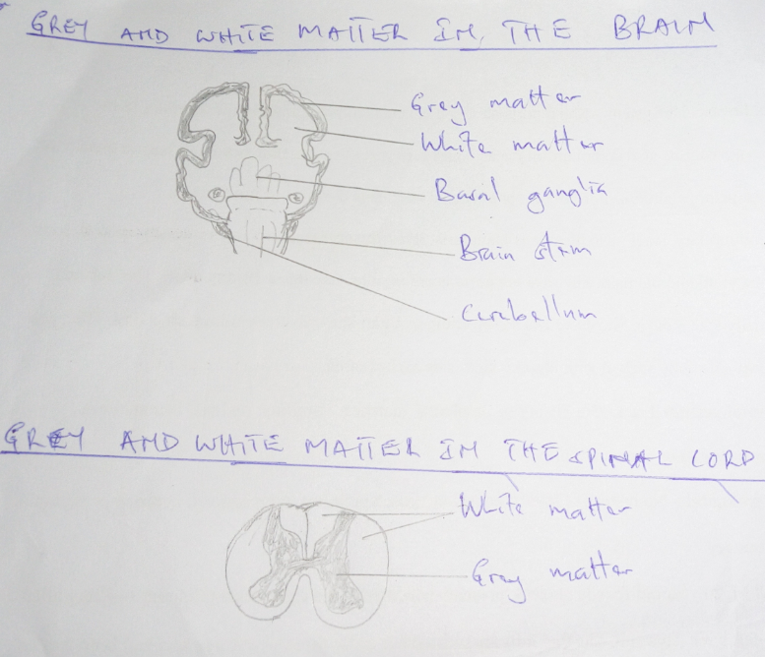
Ten: Which part of the brain is referred to as the “relay station”? Why? Which part of the brain is referred to as the “emotional brain”? Why?
The pons is a part of the brain stem which is often referred to as the relay station. It is the point of exchange of signals between the cerebellum and the cerebrum.
The limbic system, which includes the amygdala, is the emotional brain. It is the part of the cerebral cortex that is tasked with the processing of various emotions.
Eleven: Discuss the etiology of multiple sclerosis, myasthenia gravis, and osteoporosis.
Multiple sclerosis results from autoimmune destruction of the myelin sheath surrounding axons in the central nervous system.
Myasthenia gravis is an autoimmune disorder in which autoimmune antibodies are formed against the nicotinic cholinoceptors at the neuromuscular junction. Inhibition of impulse transmission at this junction results in muscle weakness.
Osteoporosis is caused by an imbalance between bone matrix deposition and resorption in which resorption predominates. The predominant resorption leads to the constant loss of bone matrix and calcium hence bone weakness. The imbalance can be caused by several entities including hormonal changes like those of menopause.
Twelve: Discuss the effects of two divisions of ANS on: lacrimal glands, iris, sex organs, and cardiac muscles.
Lacrimal glands
The sympathetic division of ANS decreases secretion while the parasympathetic increases secretion.
Iris
The sympathetic division of ANS causes contraction hence mydriasis while the parasympathetic division causes relaxation hence miosis.
Sex organs
The sympathetic division of ANS is essential for ejaculation or emission while the parasympathetic causes erection in the lead-up to ejaculation or emission.
Cardiac muscles
The sympathetic division of ANS increases cardiac muscle contractility and pace of contraction while the parasympathetic reduces both contractility and pace of contraction.
Thirteen: Define homeostasis. Give the definition of health, according to WHO.
Homeostasis is the maintenance of stable internal chemical and physical conditions within living systems.
WHO defines health as a state of complete physical, mental, and social well-being and not merely the absence of infirmity or disease.

